NEWS

FOR IMMEDIATE RELEASE
June 2025
Phoenix, Arizona
#3i

Local Executive Accepts Award in International Design Competition

Jeremy Koth, Metallurgist, DSB Technologies, Janesville, Wisconsin, accepted a Grand Prize Award in the Conventional Automotive Engine Category the 2025 Powder Metallurgy Design Excellence Awards Competition. The award was given for a urea flange that connects a urea injector to a diesel engine's exhaust system.

He accepted the award for his company at PowderMet2025: International Conference on Powder Metallurgy & Particulate Materials in Phoenix, Arizona.

Powder metallurgy (PM) is an automated metalworking process that forms metal powders into precision components used in applications such as auto engines and transmissions, hardware, outdoor power, industrial machinery, sporting goods, defense, and firearms. More than 800 million pounds of PM parts are made annually in North America.

The competition is sponsored annually by the Metal Powder Industries Federation, an international trade association for the metal powder producing and consuming industries.
# # #

Editor's Note: For further information contact Dora Schember at dschember@mpif.org or (609) 452-7700.

Urea Flange

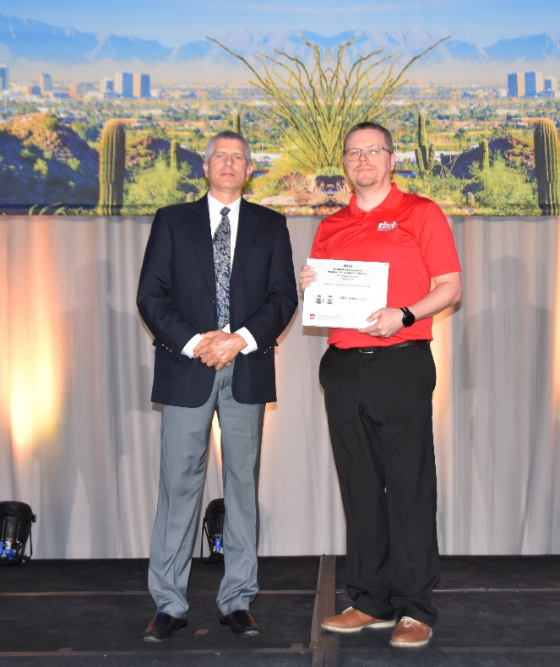
MPIF President Mike Stucky (left) presents award to Jeremy Koth

For more information or digital images contact Dora Schember (dschember@mpif.org)
Metal Powder Industries Federation
105 College Road East, Princeton, NJ 08540-6692
609-452-7700 mpif.org
About the Metal Powder Industries Federation
Metal Powder Industries Federation is the North American trade association formed by the powder metallurgy industry to advance the interests of the metal powder producing and consuming industries and provides a single point of reference for all MPIF member companies.

